**Operating Systems – Assignment 1**

ID: 322623323

Github: https://github.com/roymamon/Operating-Systems-1/tree/main

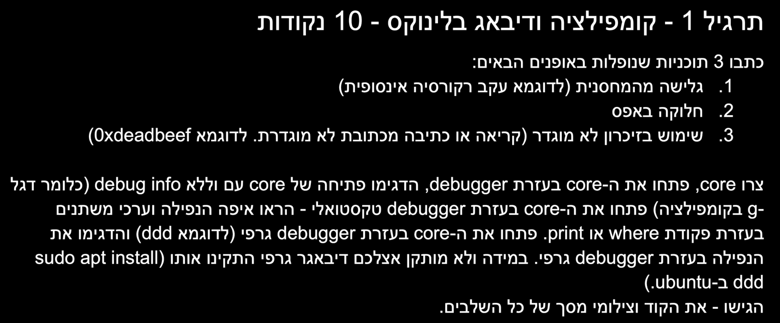

1. stack overflow:

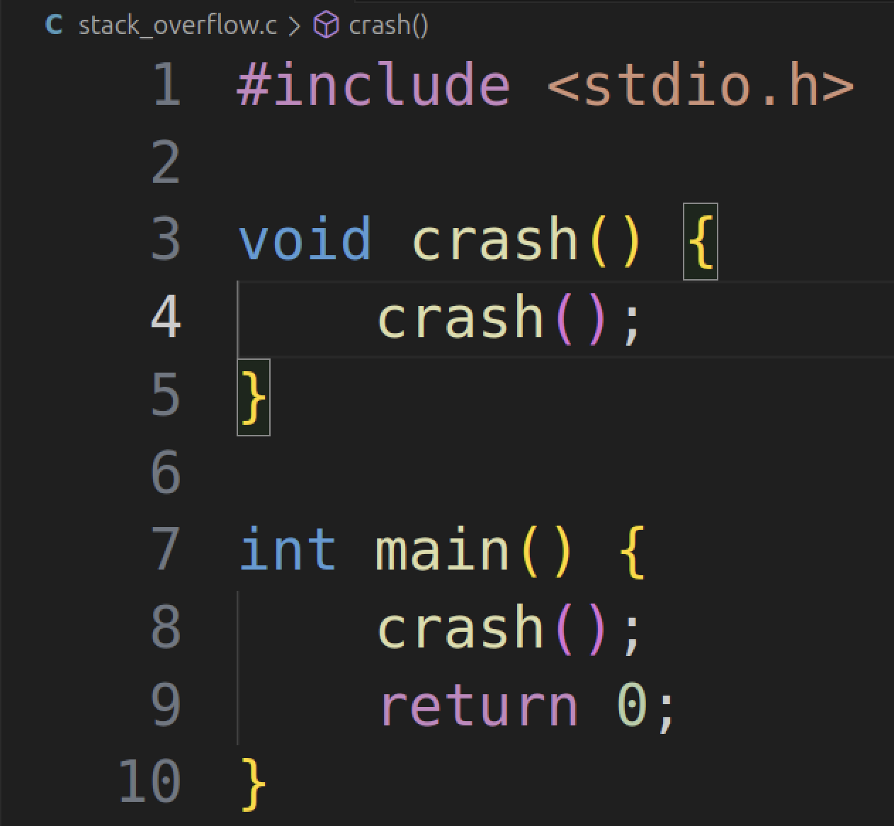

With debug info:

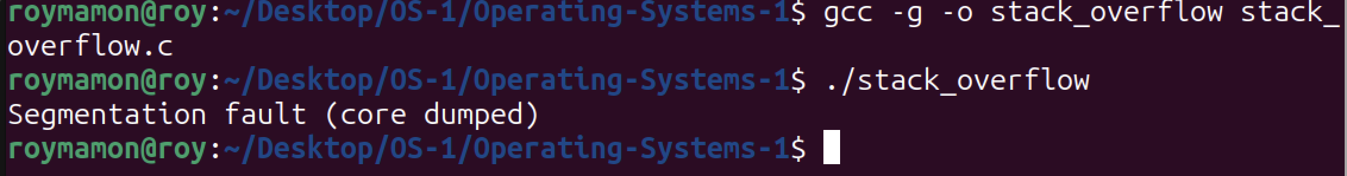

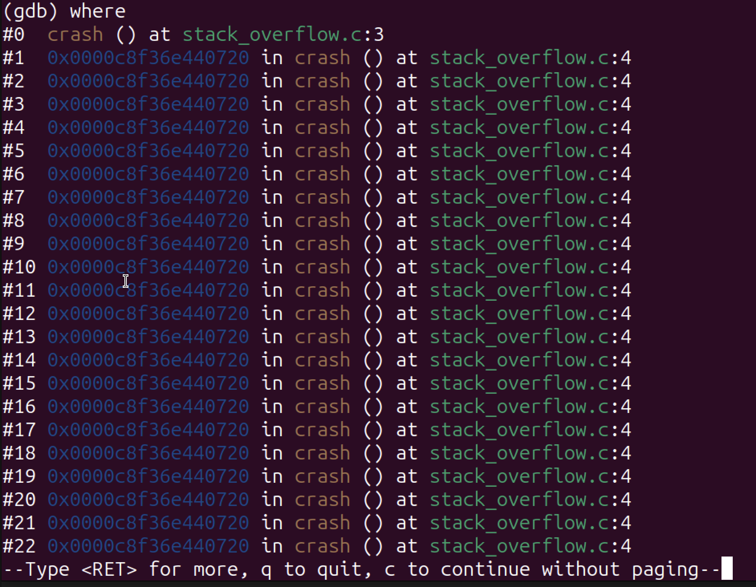

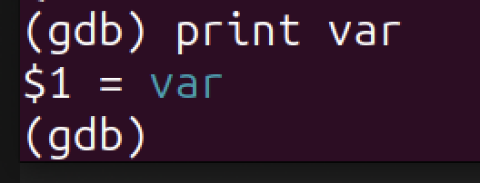

After many attempts to make “ddd” work on my Mac, I used something else for the graphic part – “gdbgui”

https://www.gdbgui.com

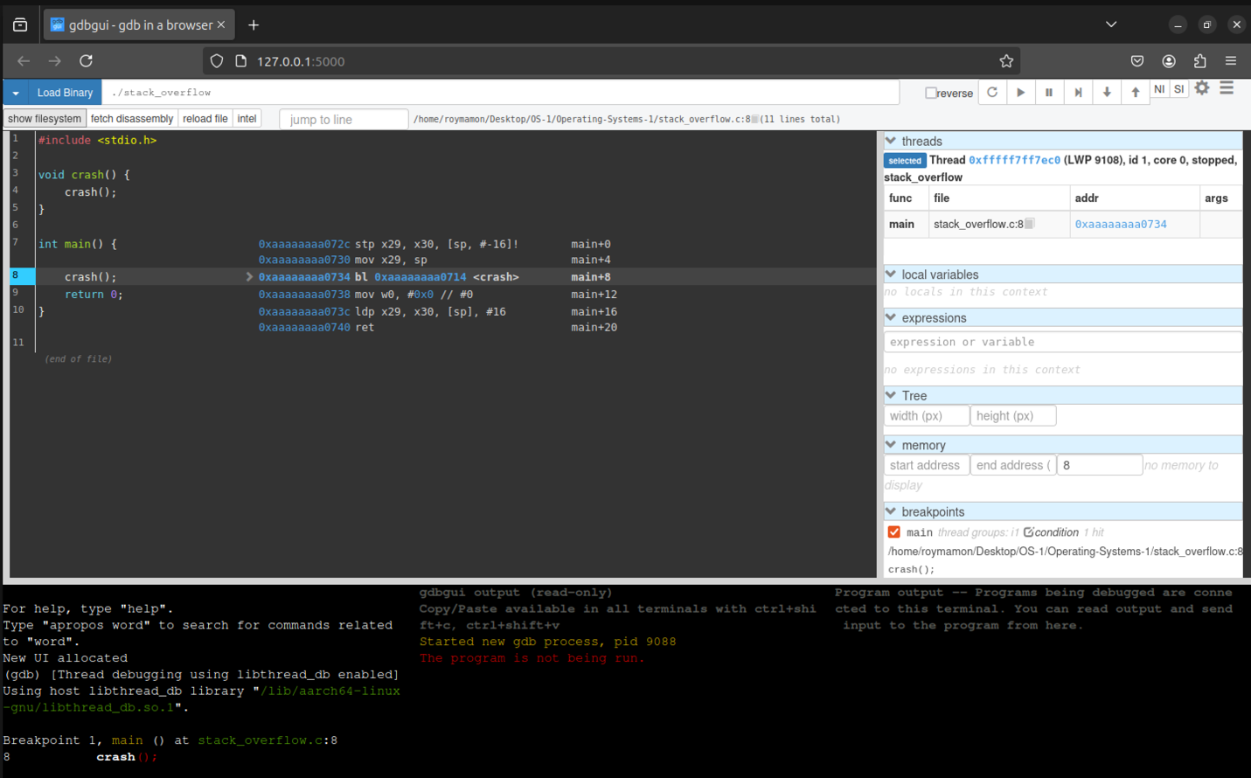

Without debugging flag:

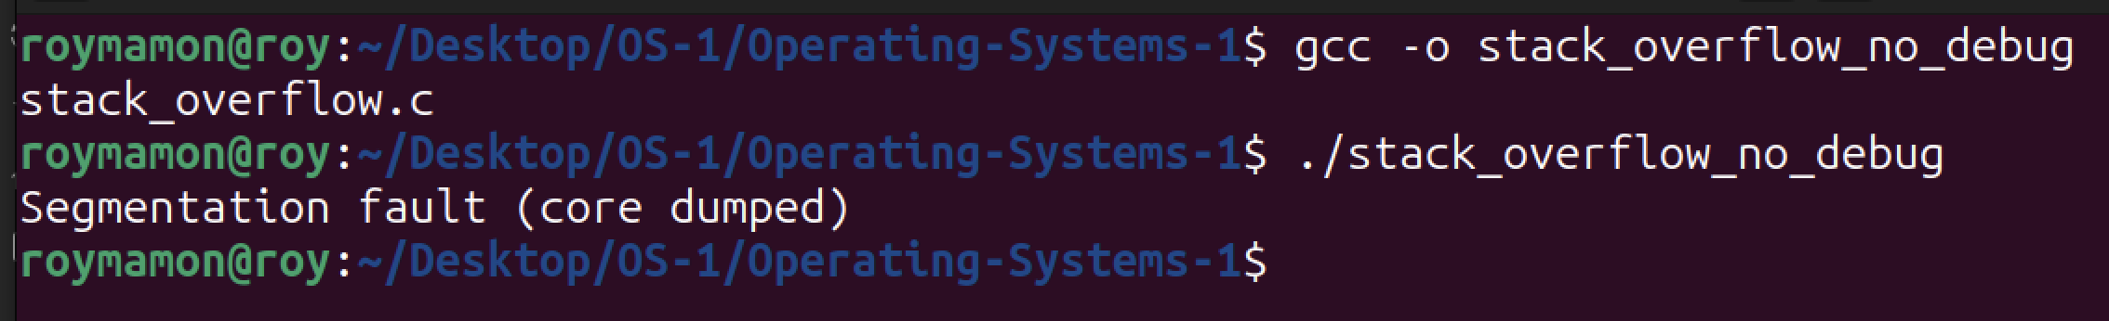

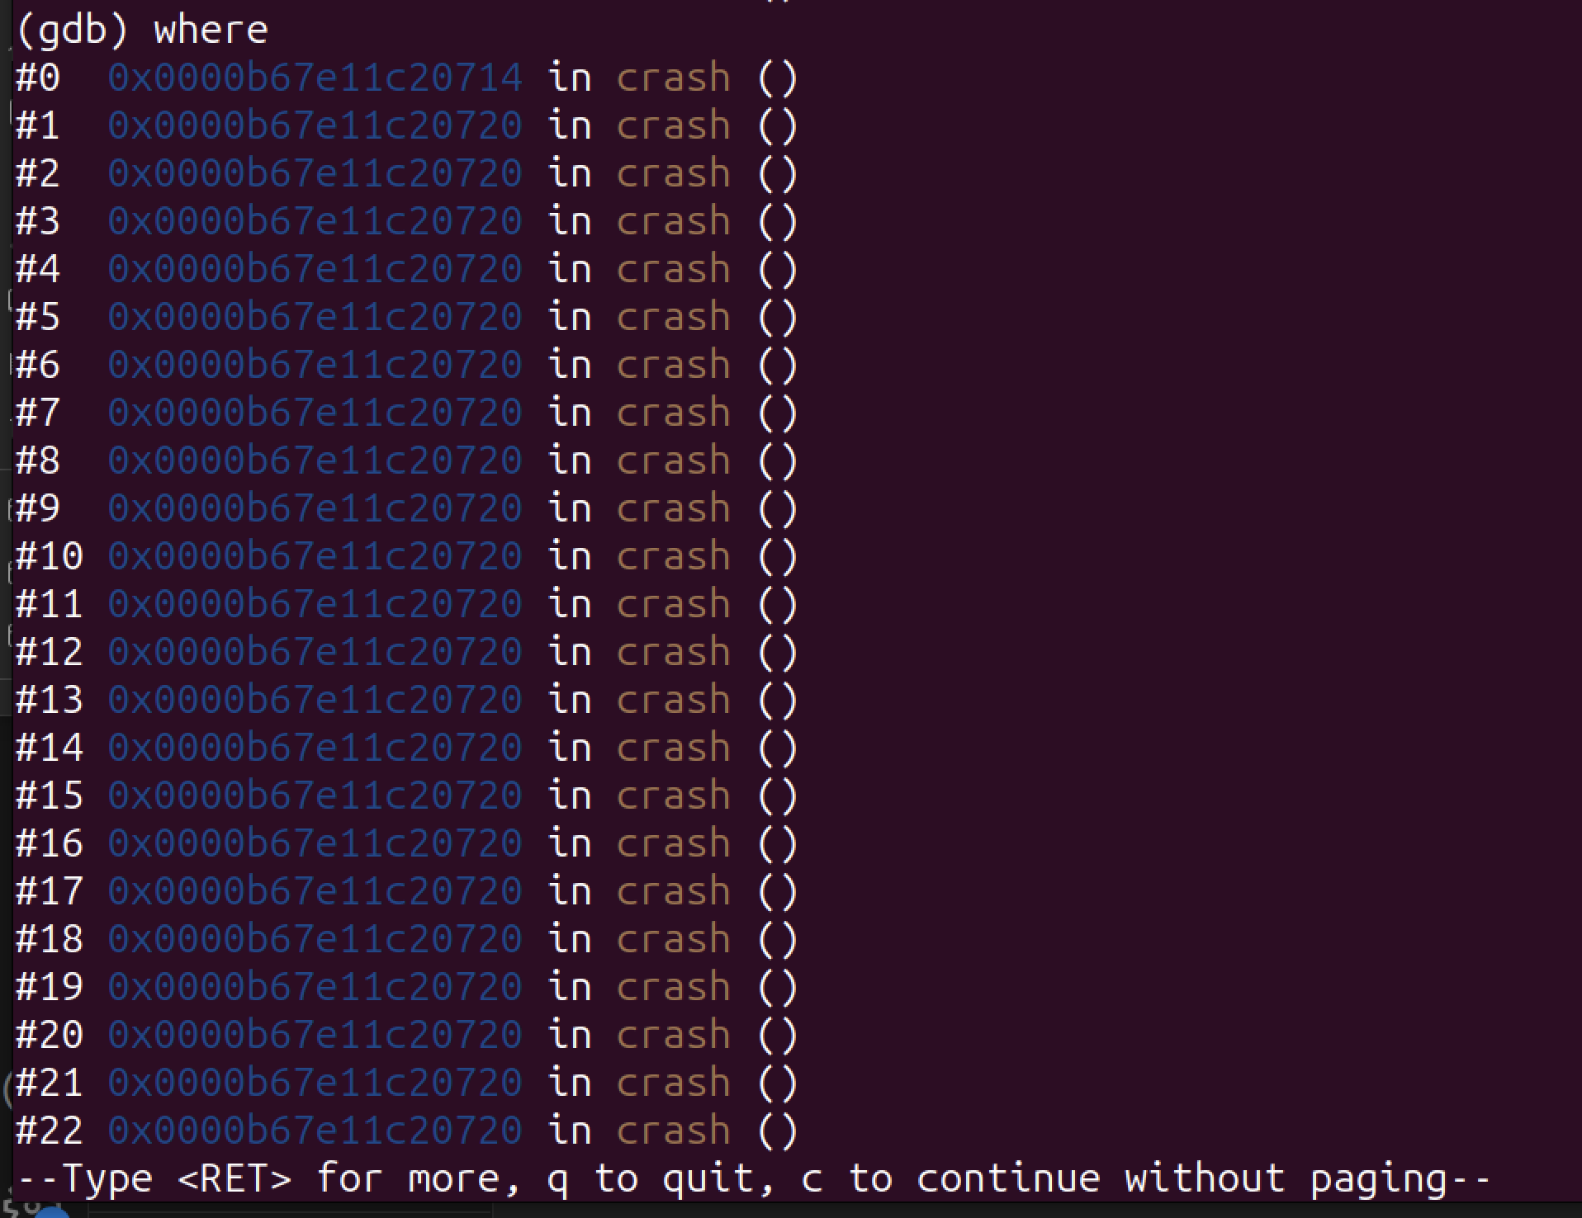

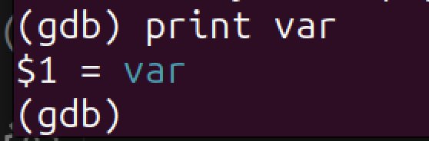

2. division by zero:

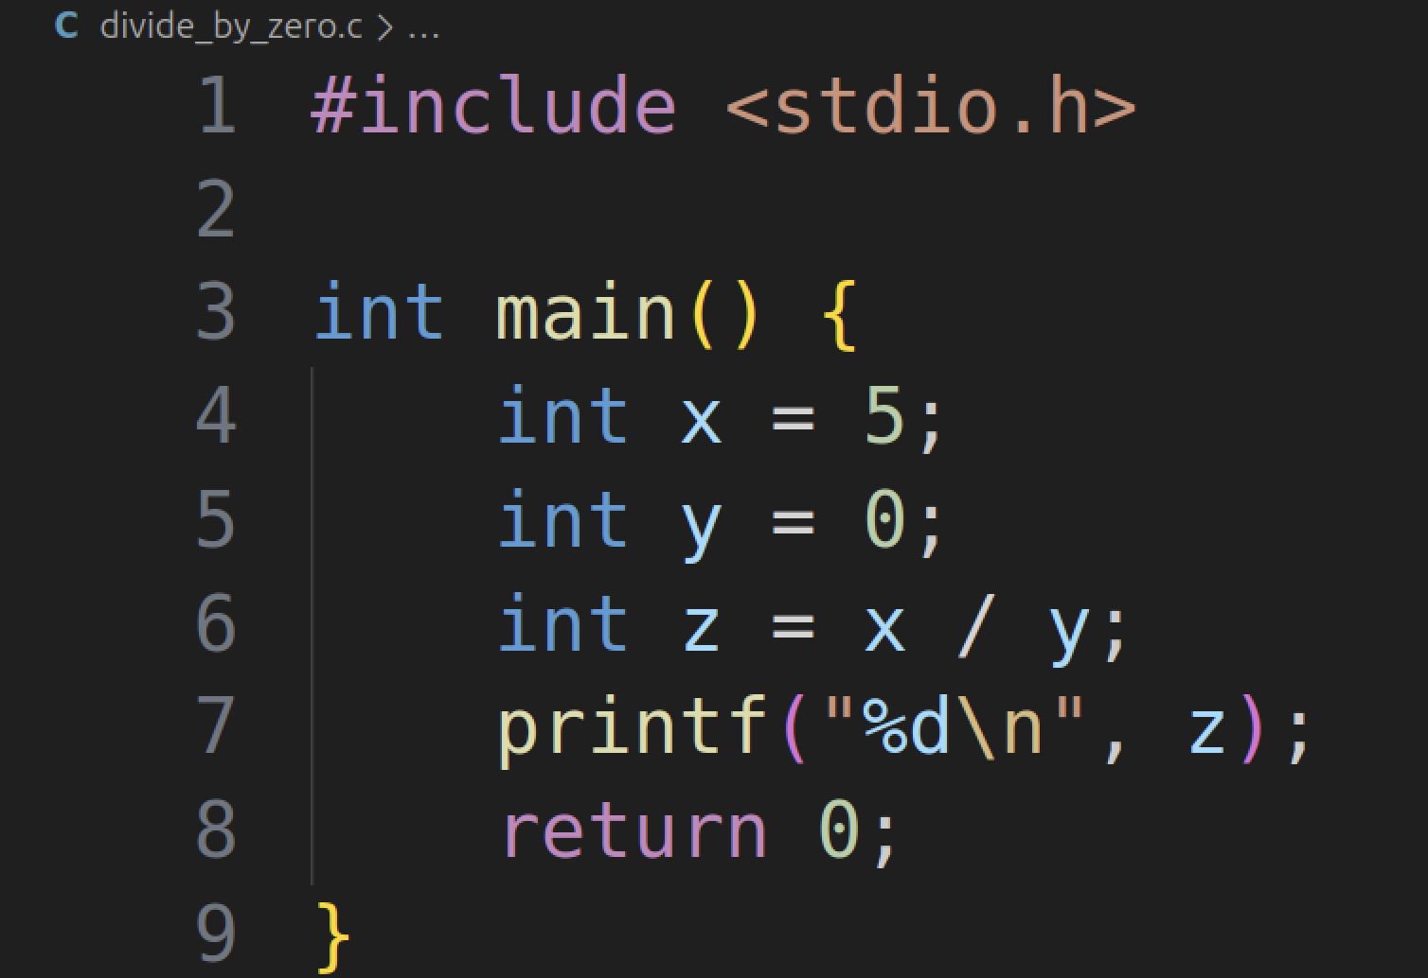

With debug info:

After many attempts to divide by zero, my program wouldn’t crash, it just returned “0”, this is also maybe due to the fact that im using Mac.

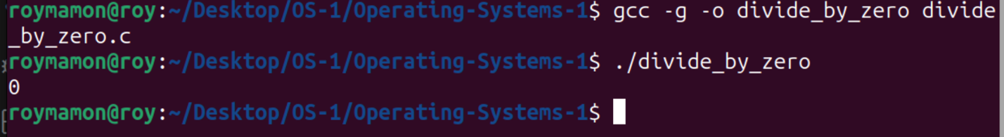

So eventually, I forced a floating point crash (the dividing by zero crash) using raise(SIGFPE)

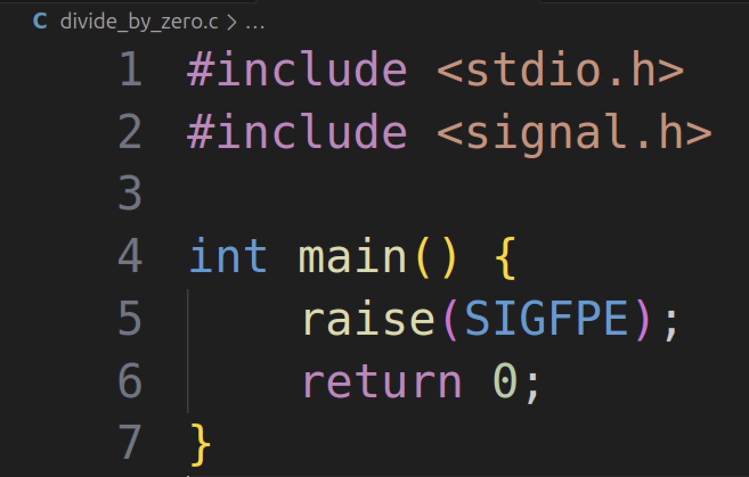

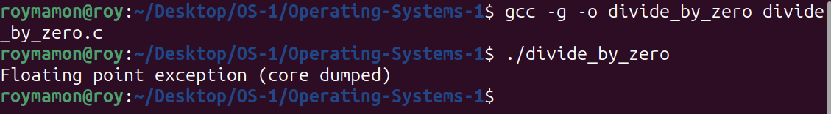

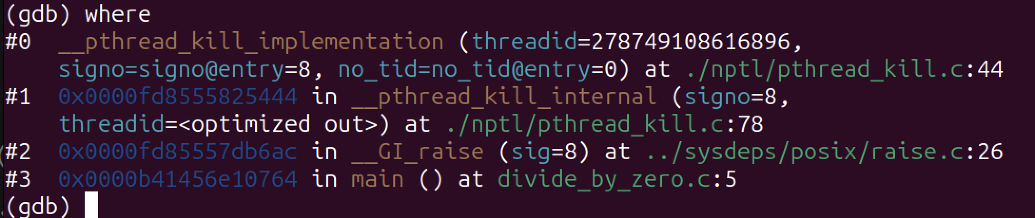

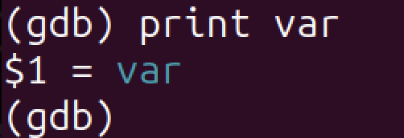

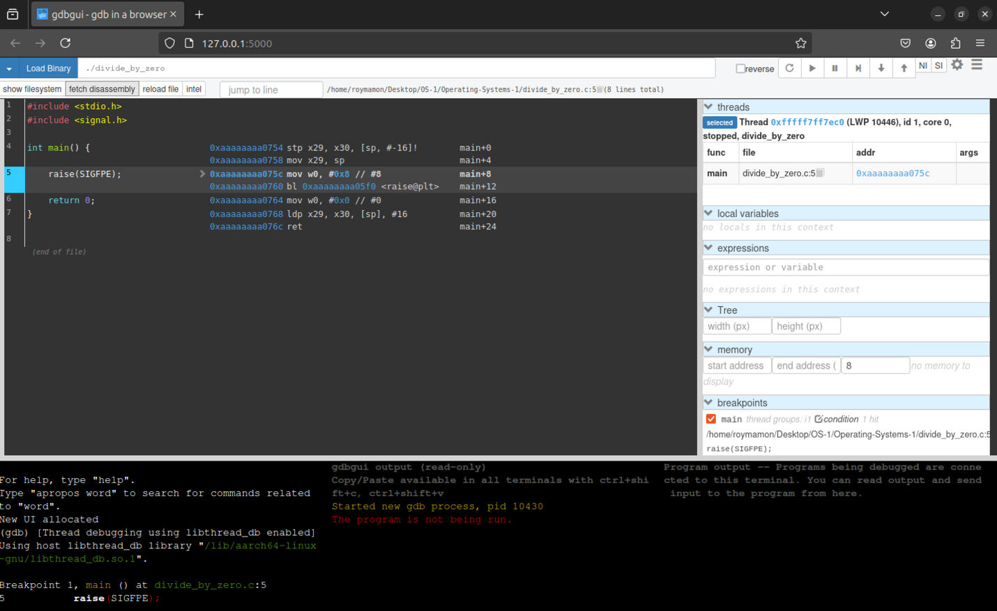

Without debug flag:

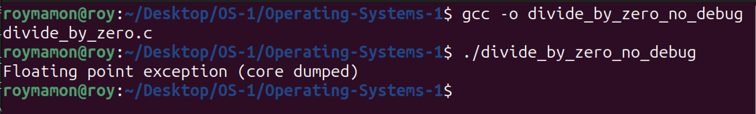

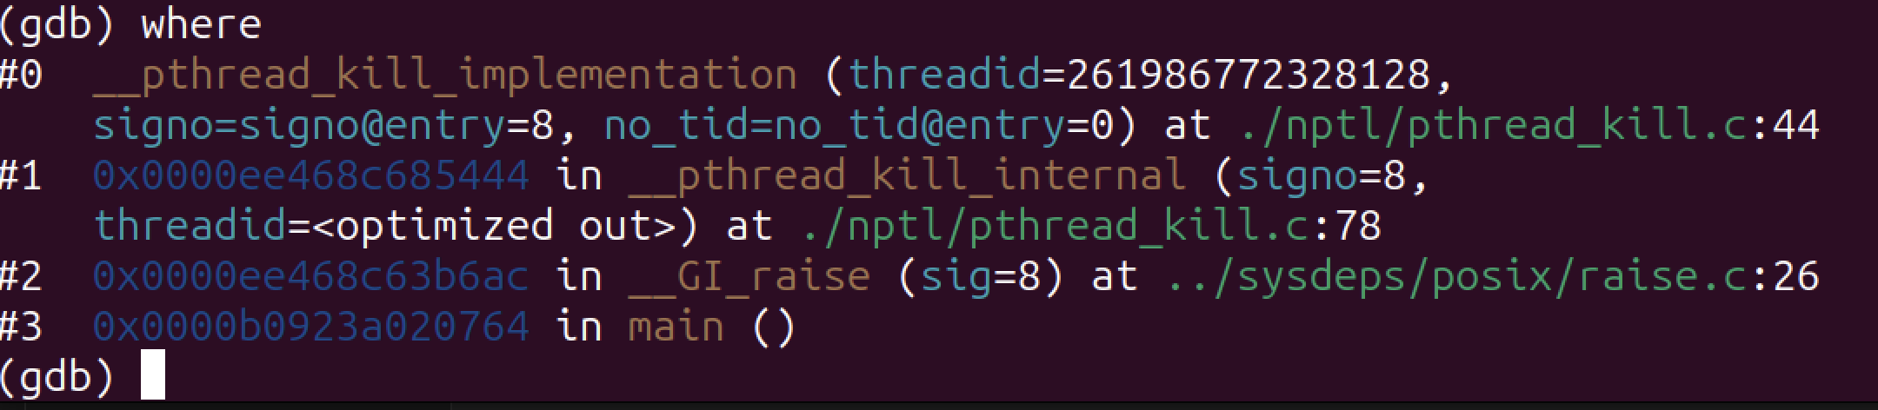

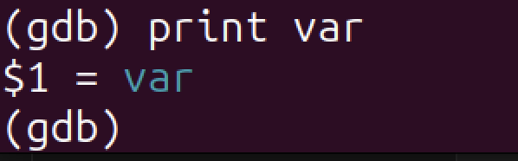

3. invalid memory address

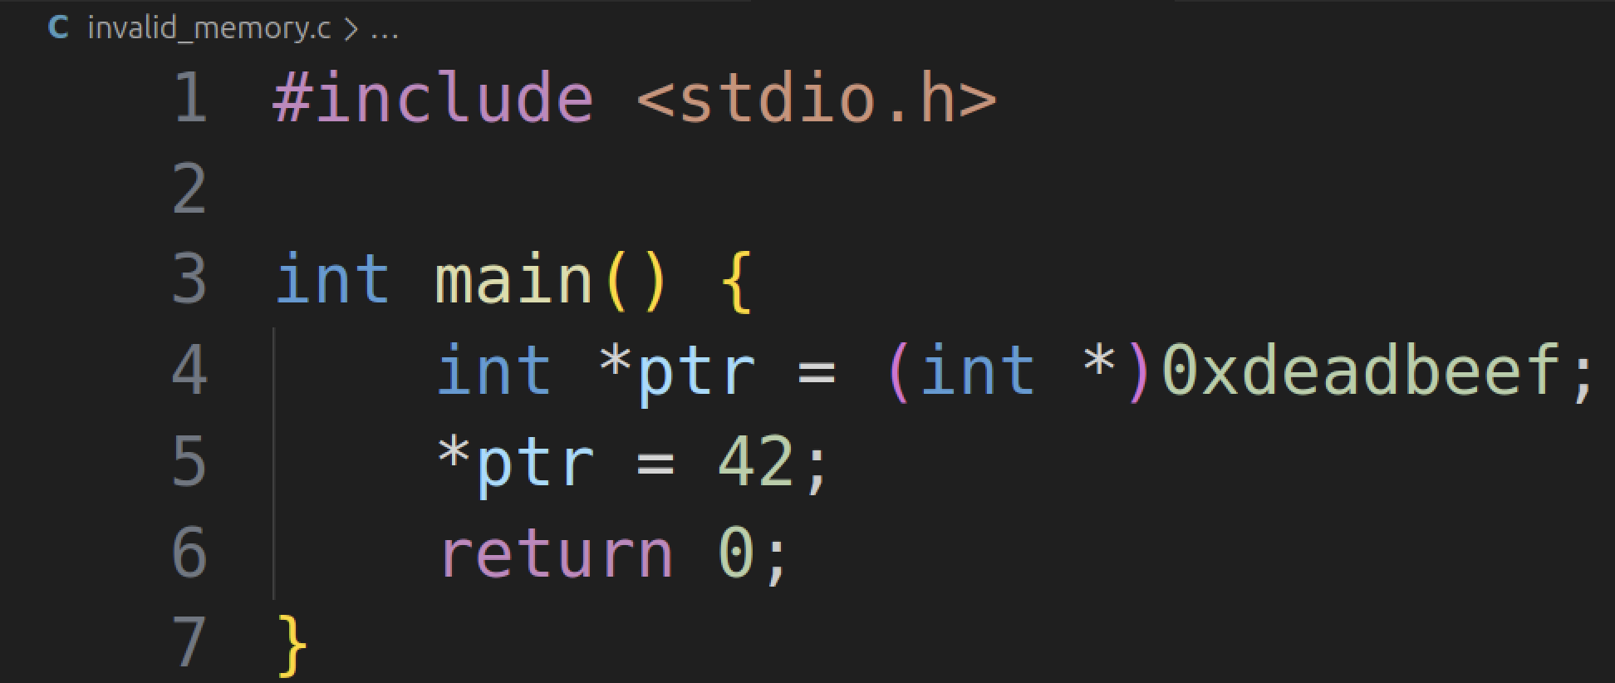

With debug flag:

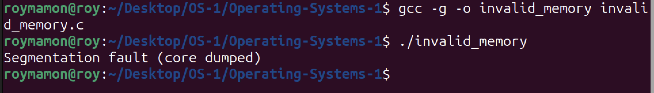

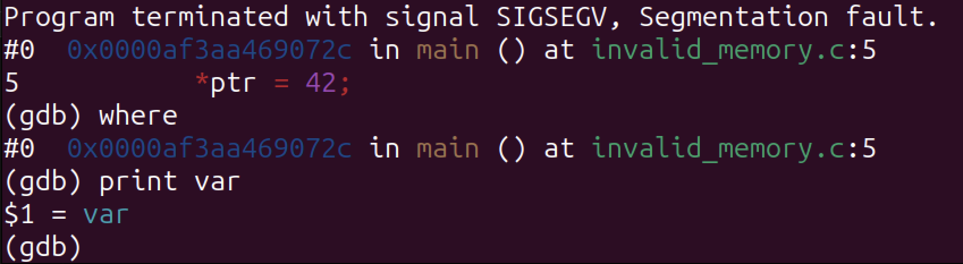

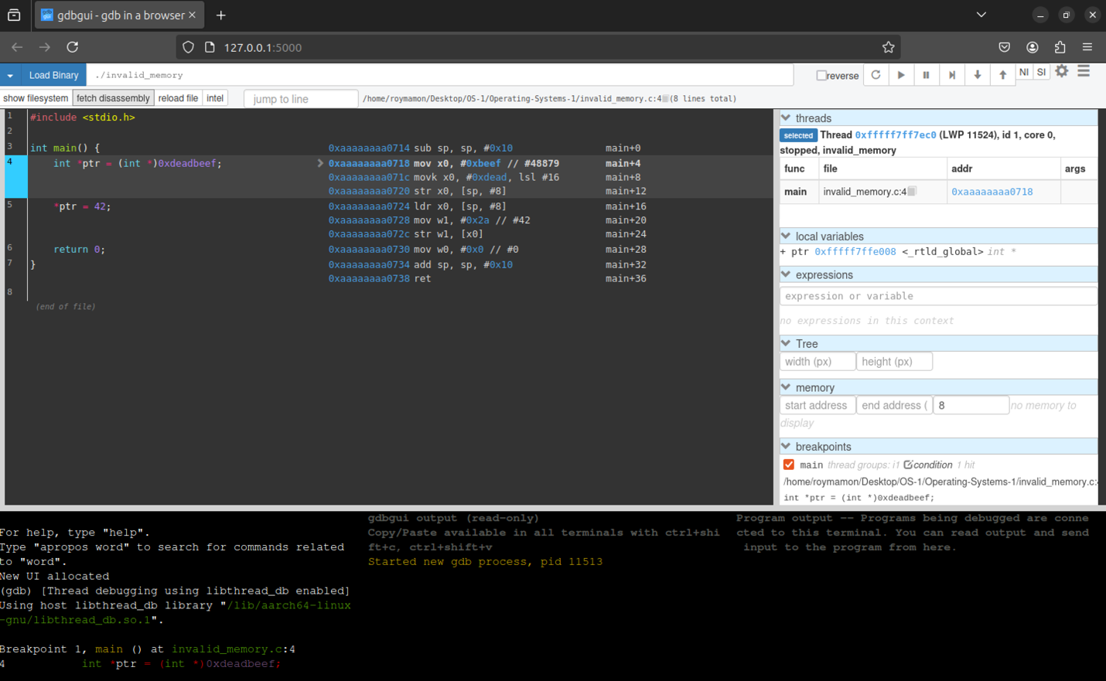

Without debug flag:

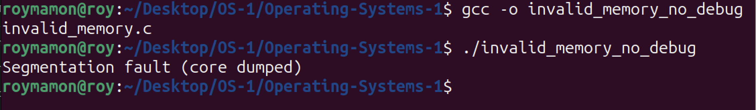

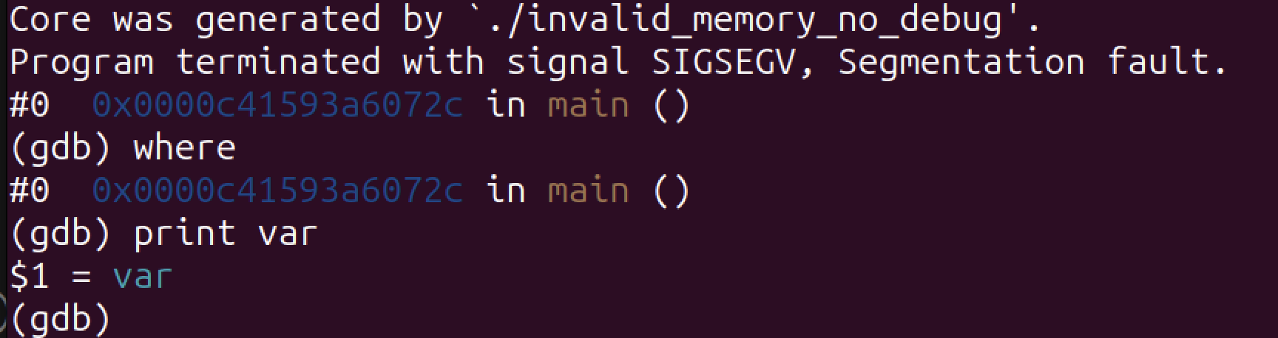

Makefile:

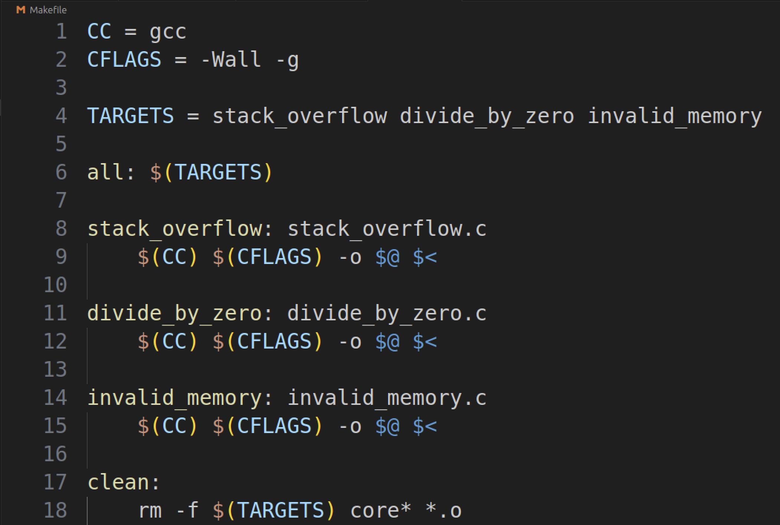

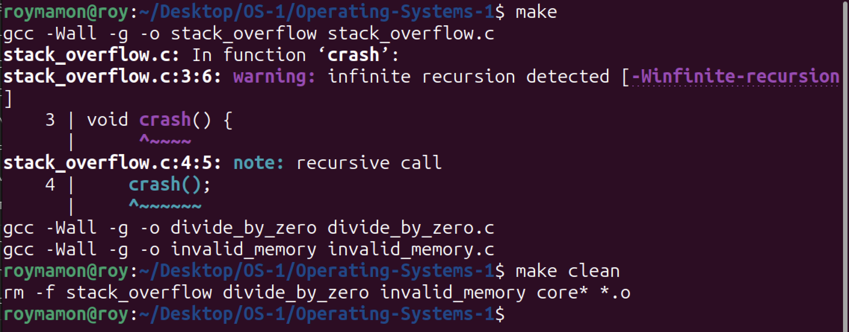

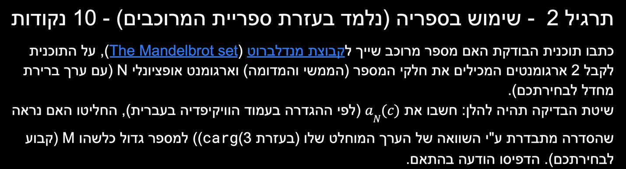

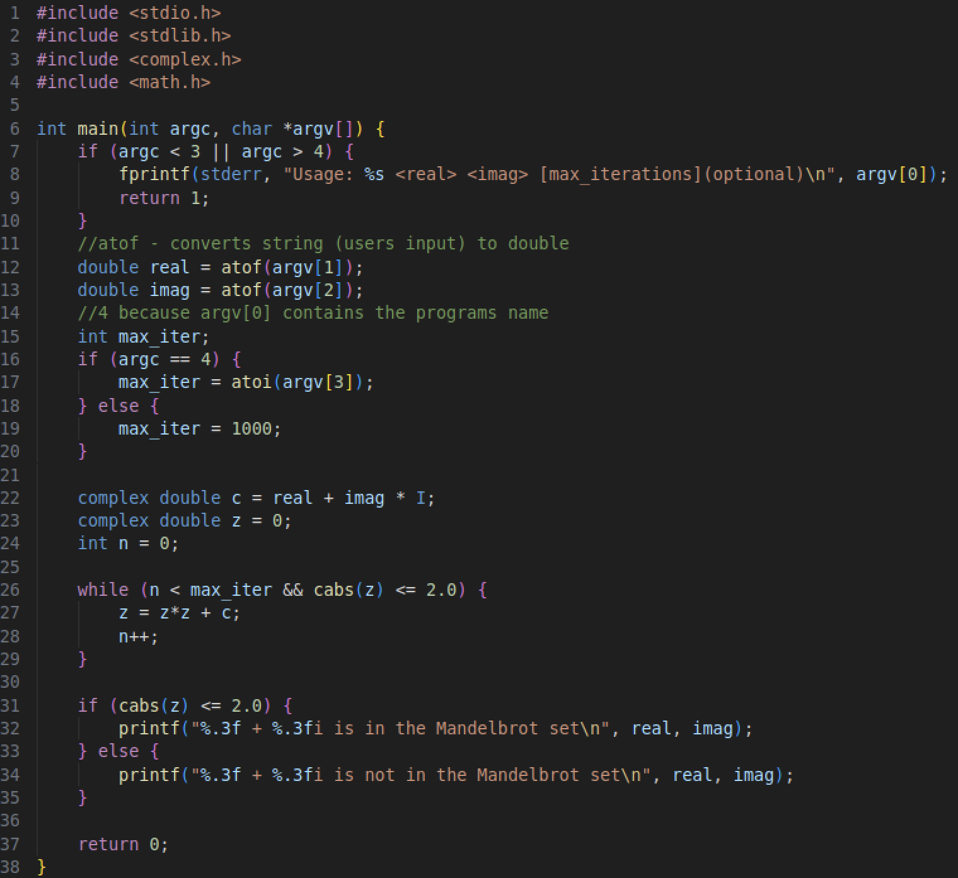

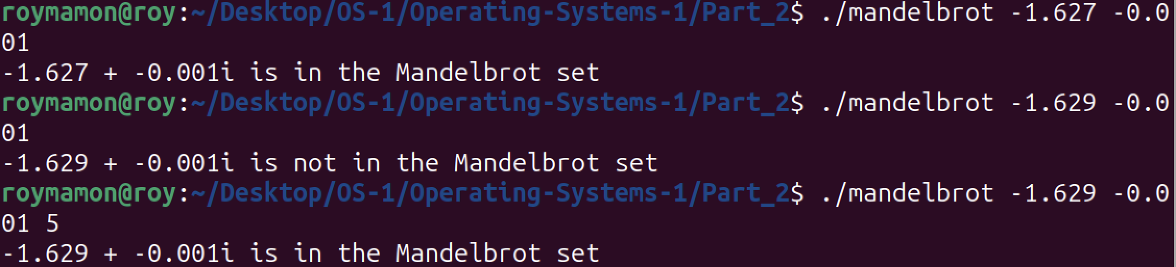

Invalid amount of arguments:



Makefile:

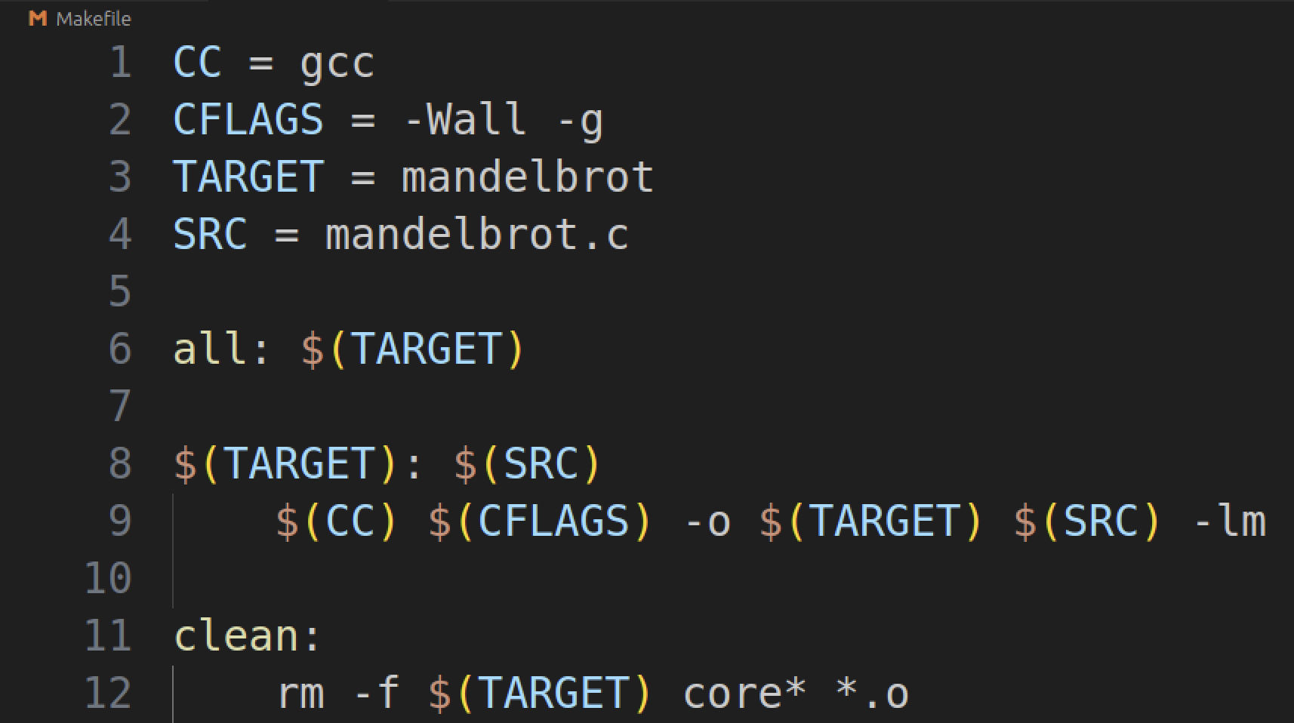

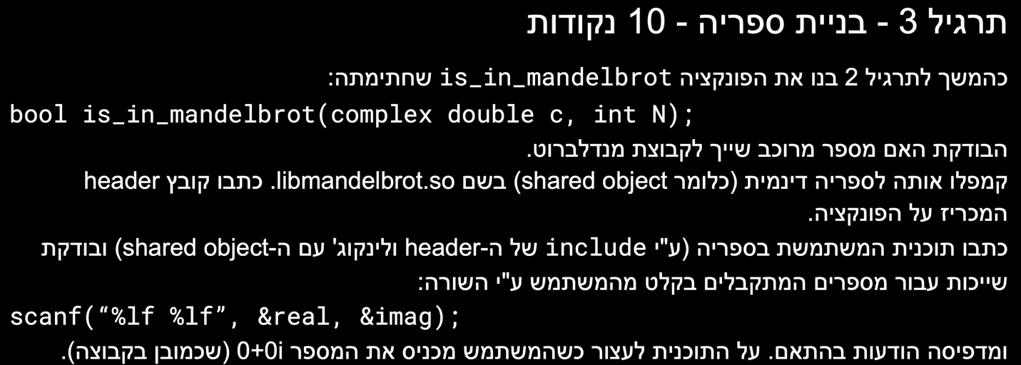

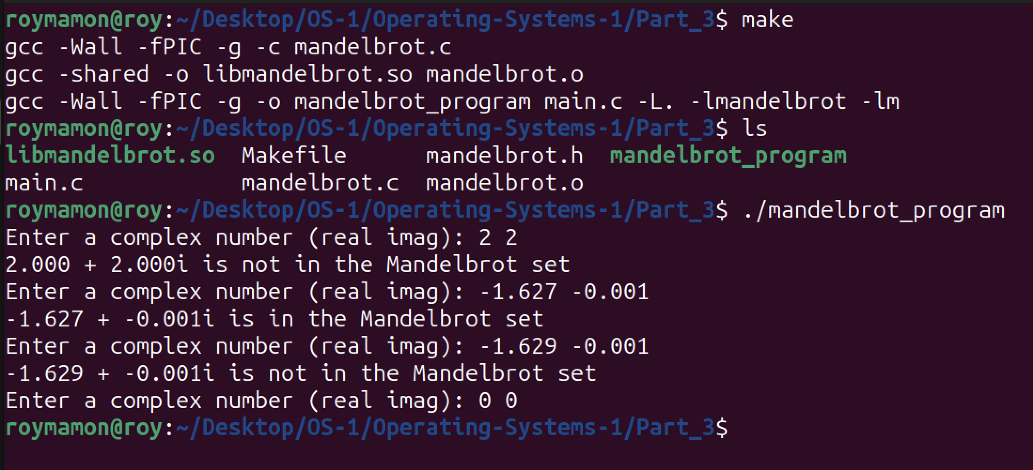



הרצה של מטריצה תקינה כמו בדוגמא ב-geeksforgeeks

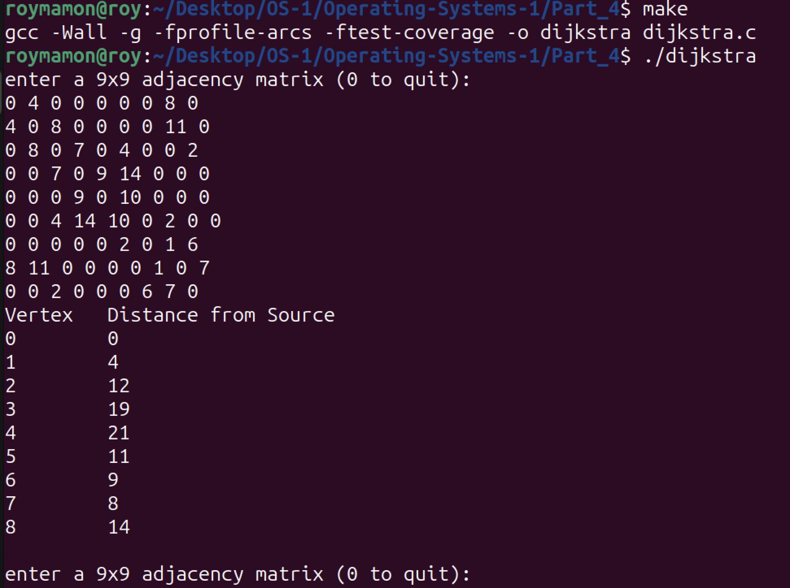

יותר מדי מרחקים בשורה:

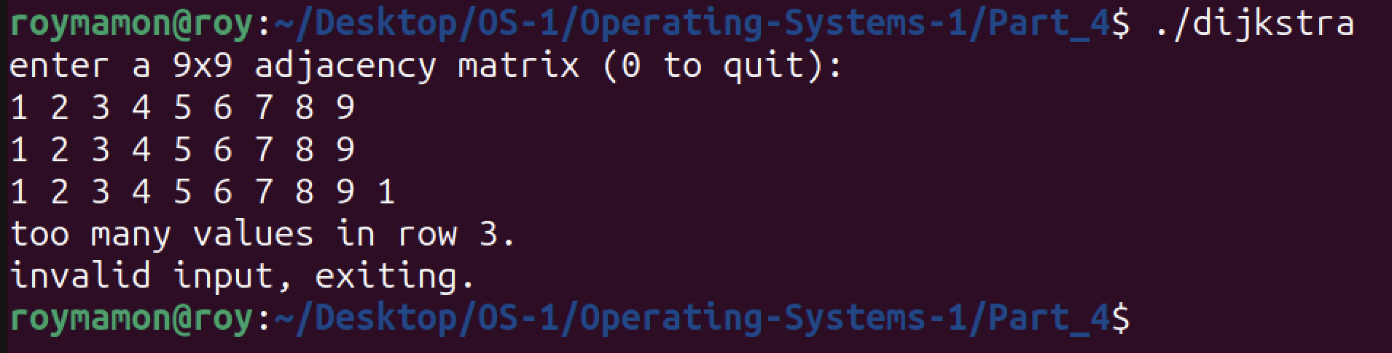

פחות מדי מרחקים בשורה:

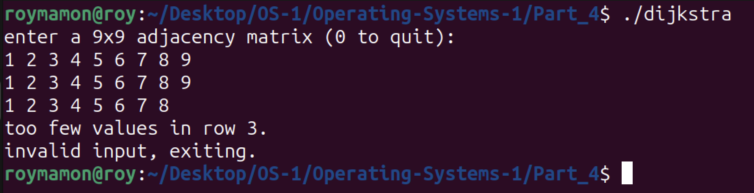

משקל שלילי:

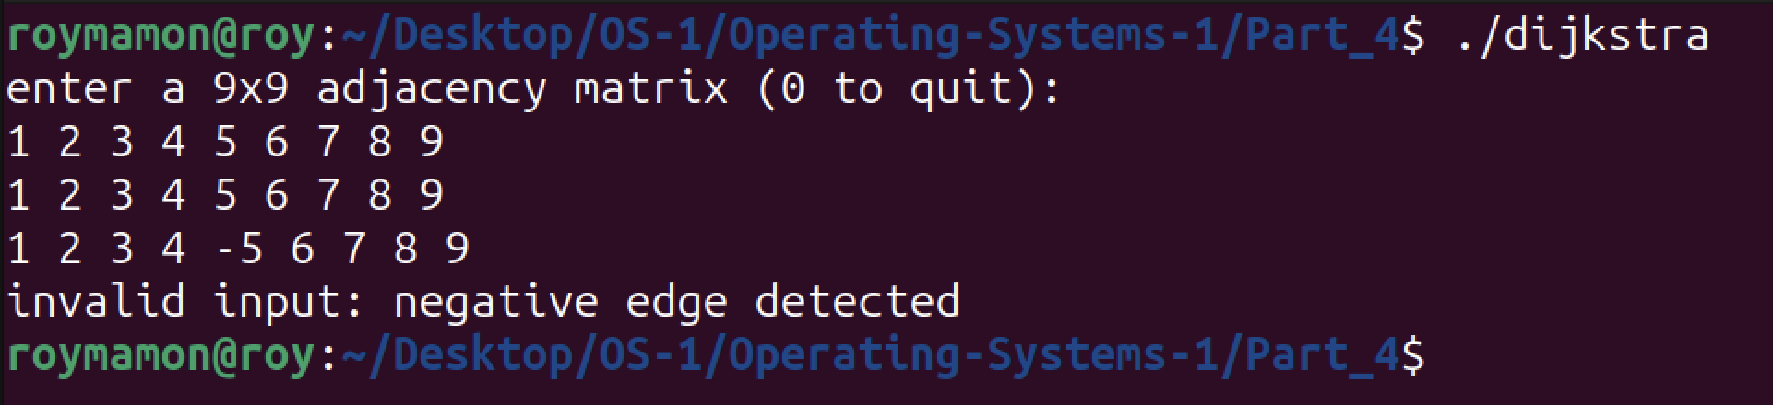

gcov:

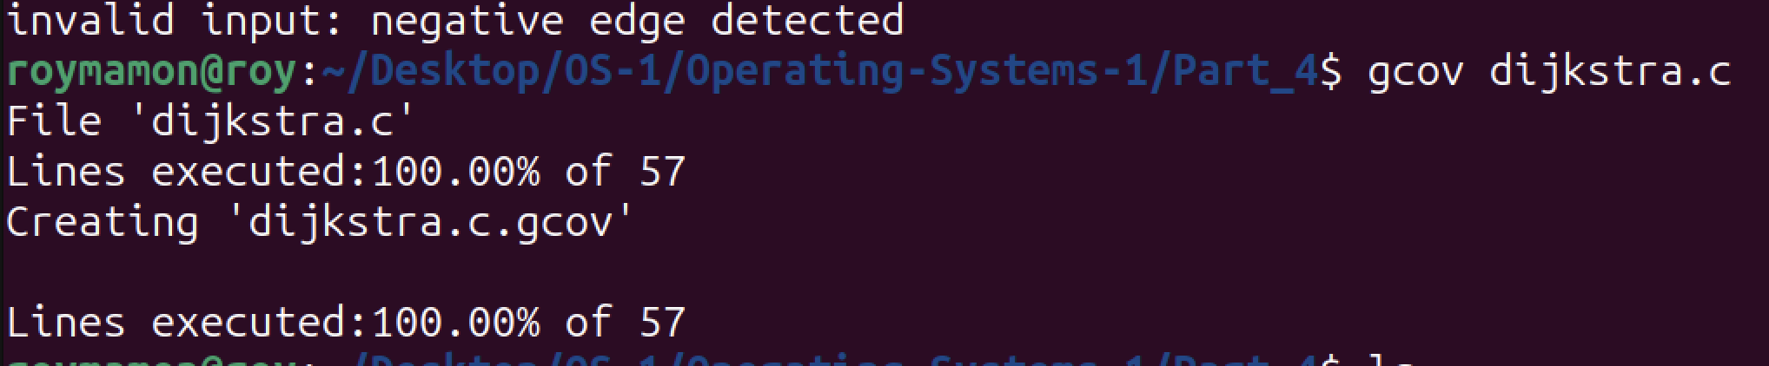

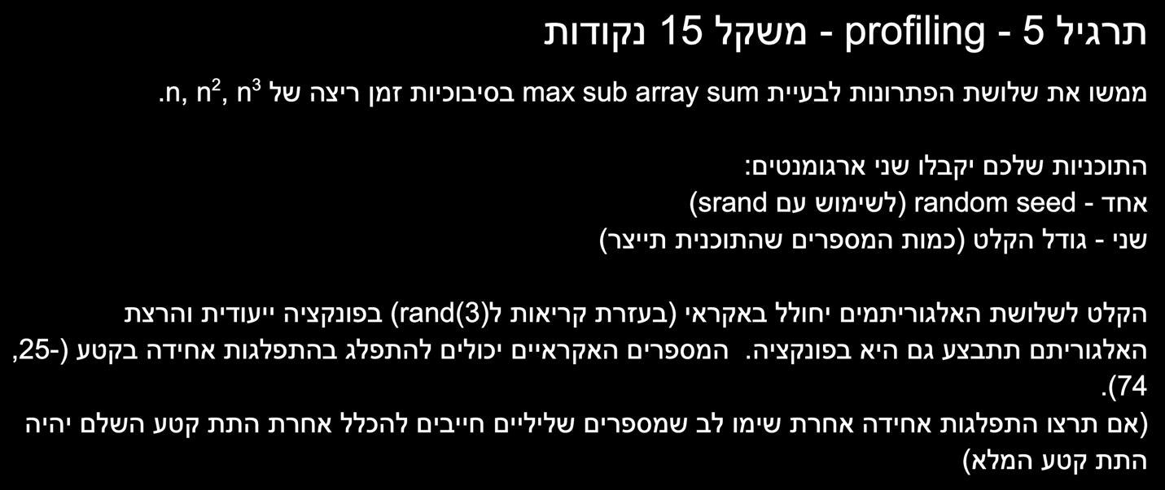

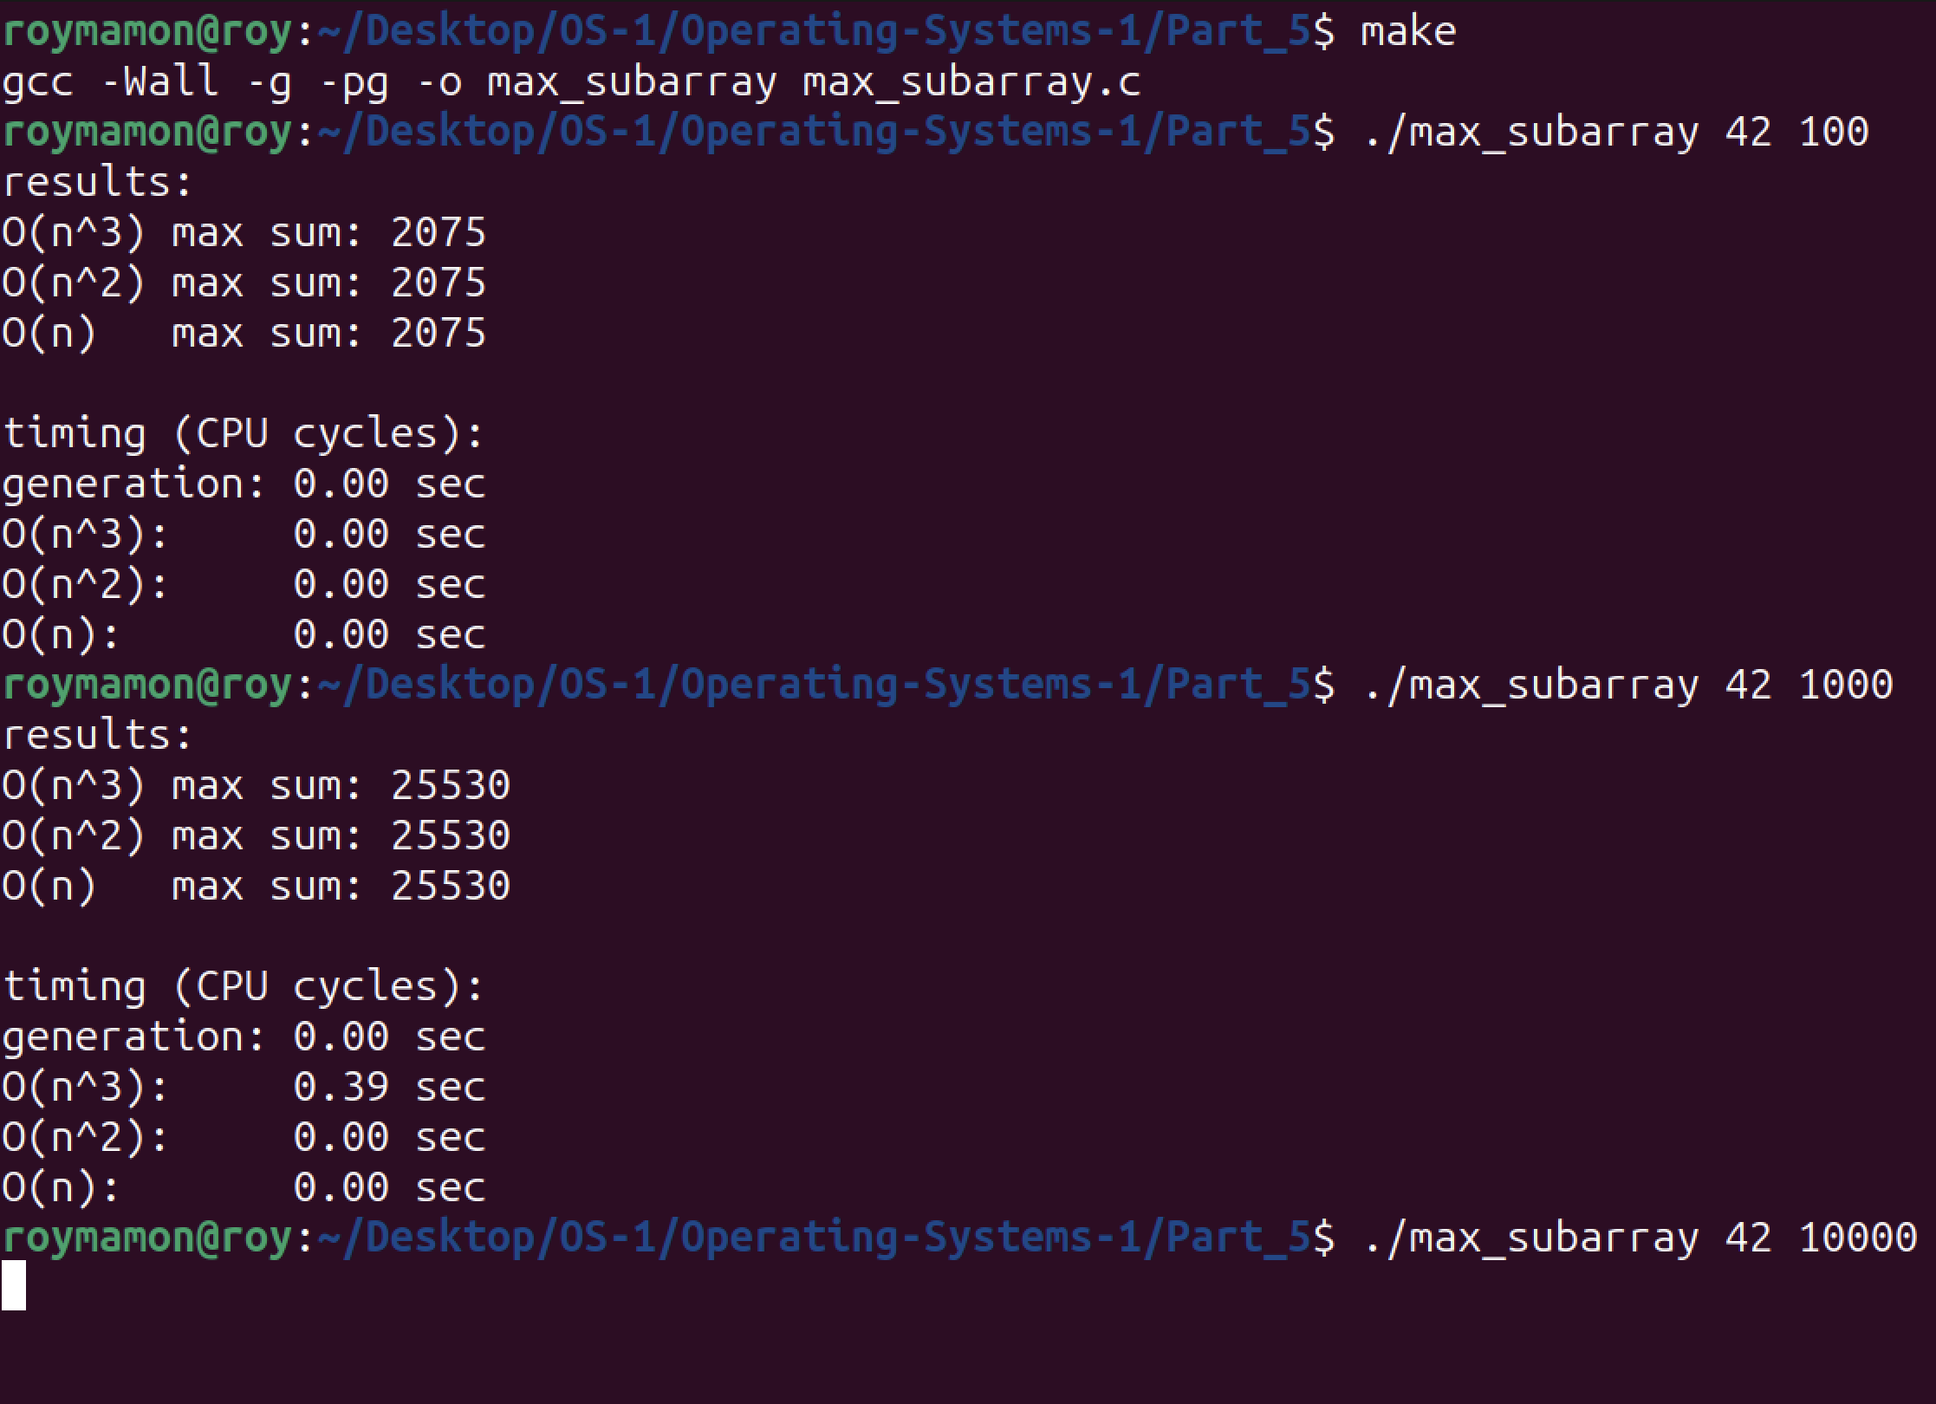

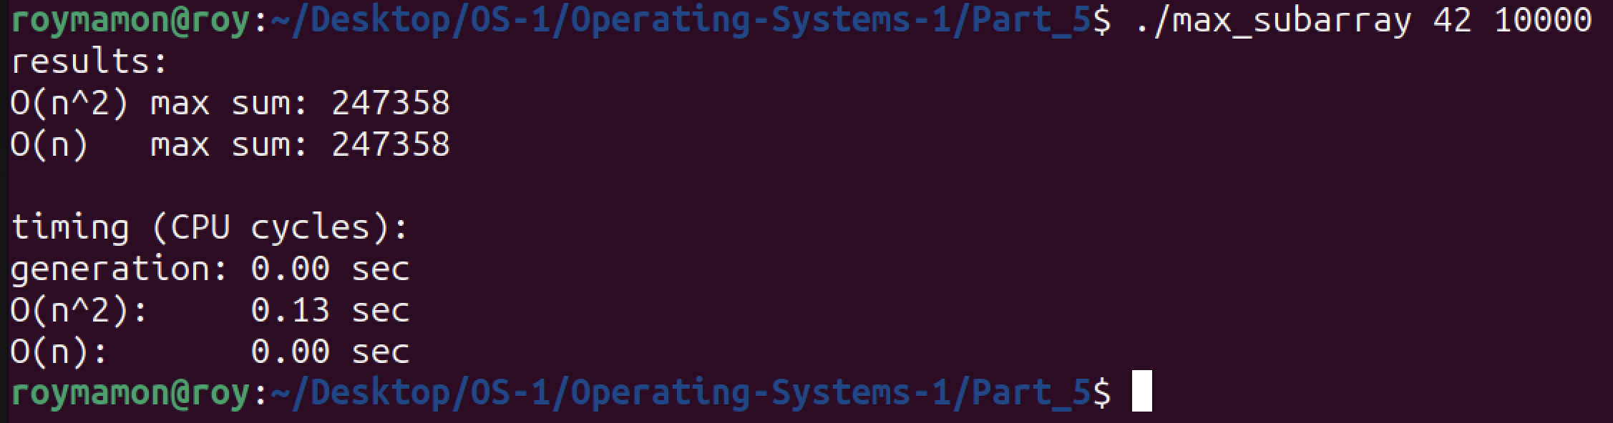

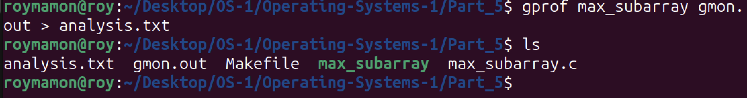

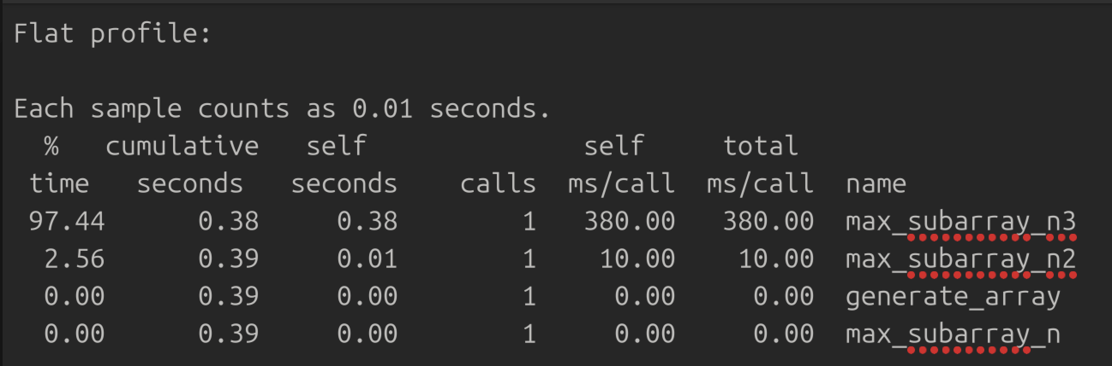



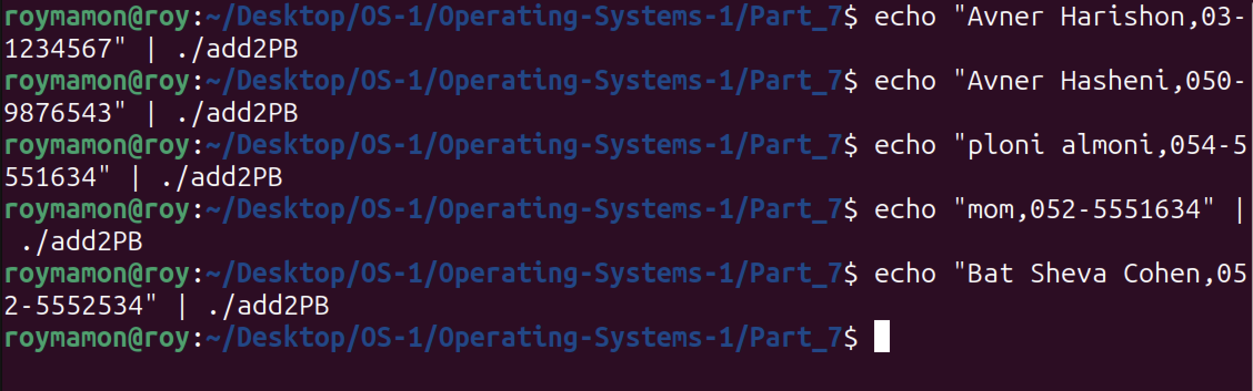

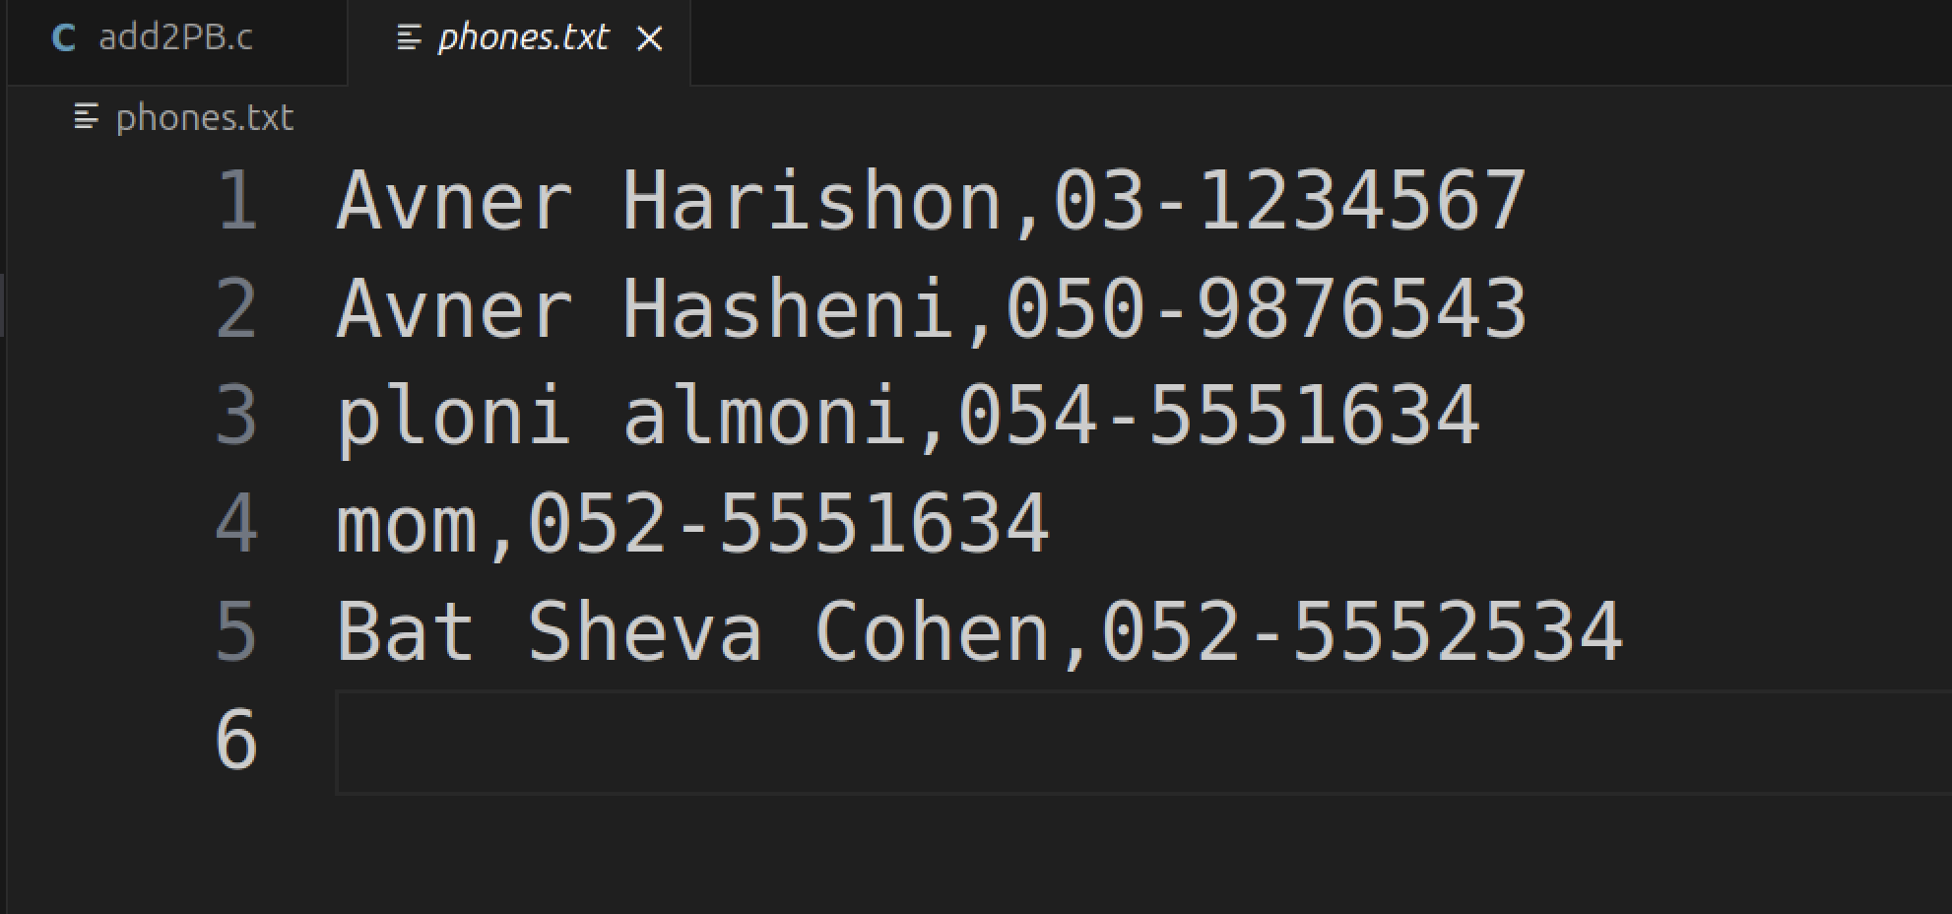

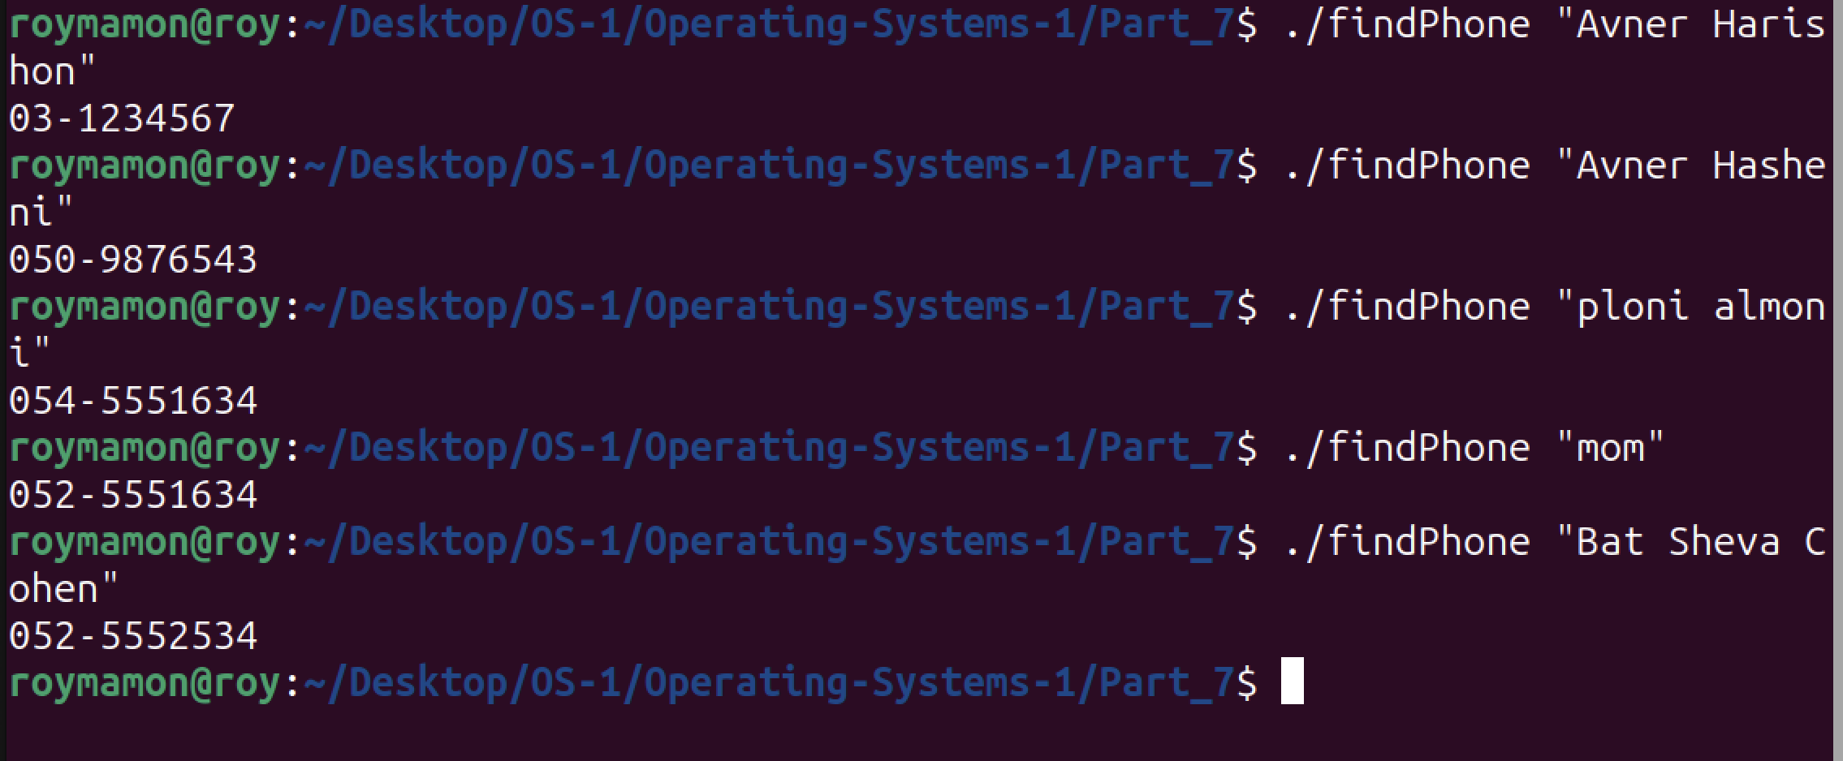

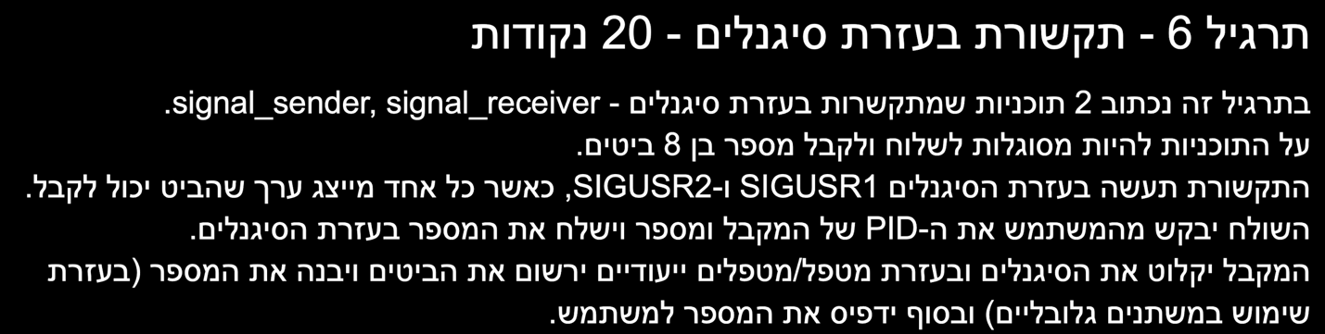

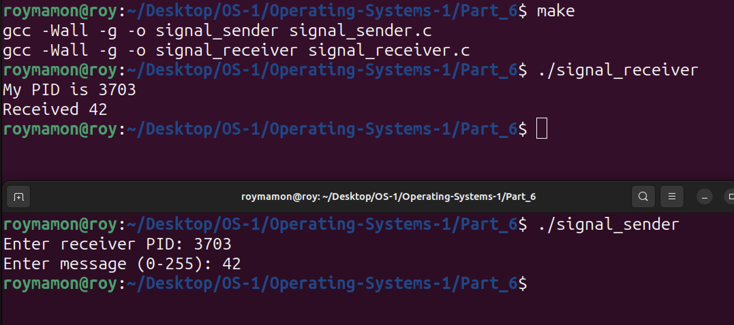

What happens if a signal is received during sleep and what should be done after?

When a signal is received during sleep, the sleep is interrupted, it doesn’t resume. The handler is executed and after it finished the process continues from where it was after the sleep.

What should be done?

Use pause instead of sleep

Or,

Use a loop around sleep that makes sure the sleep continues from when it was interrupted.